Sprint 2:

Task 1: ERD diagrams for star schema
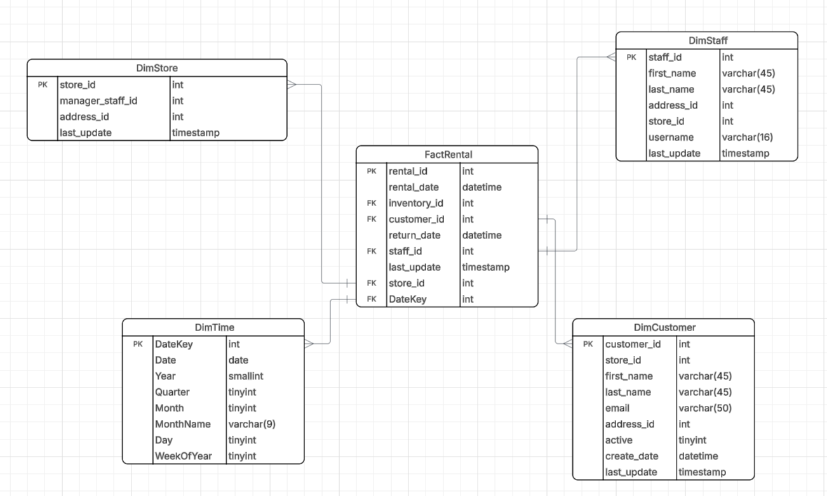

Timeline & activity (Q4: Operational Timeline)
- What is the number of rentals by month/quarter/year, and when are the peak activity periods?
- What is the first and last rental date in the dataset (operational time span)?
- How does rental volume trend over time per store?
- What is the average rental duration (return_date − rental_date) by month/quarter?
- What day-of-week or seasonal patterns do rentals exhibit?

Stakeholders (Q2: Stakeholder Identification)
- Who are the most active customers by rental count?
- How does customer activity evolve over time (new vs. existing customers using create_date)?
- Which staff members handle the most rentals?
- What is the workload distribution across staff by month/quarter?
- Which staff show shorter/longer average rental durations for the transactions they process?
- Geographic / footprint via stores (Q3: Geographic Footprint)
- Which stores generate the highest rental volume?
- How does rental activity by store change over time (growth/decline)?
- What share of total rentals does each store contribute in a given month/quarter/year?

Operational quality & patterns (supports Q4/Q2)
- What is the on-time vs. late return rate over time and by store or staff?
- What is the repeat-rental rate per customer (retention/loyalty proxy) over time
- What is the median/95th-percentile rental duration by store?
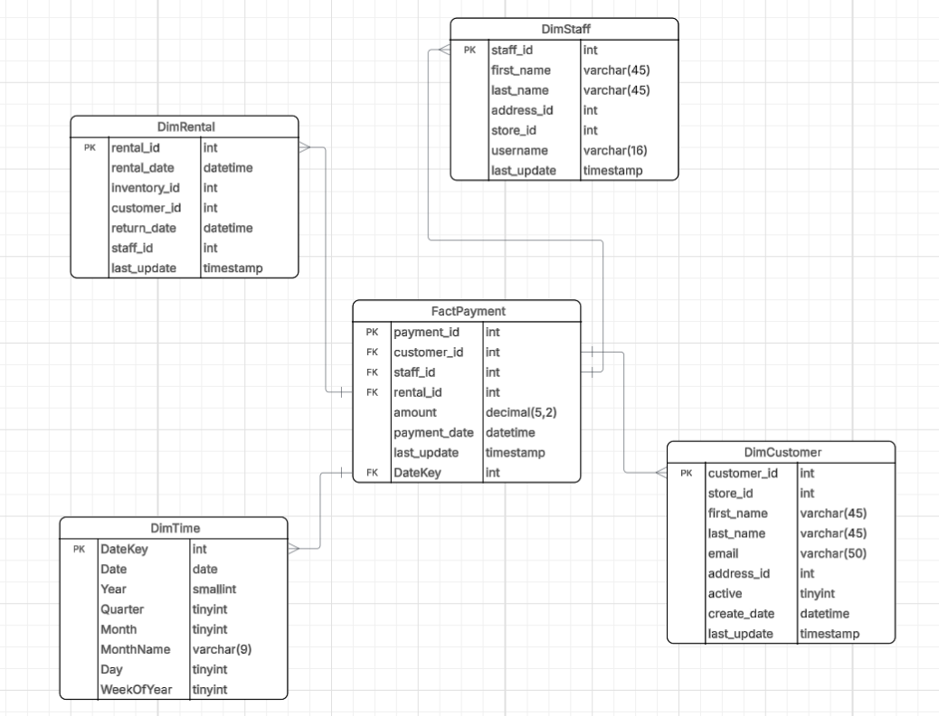

Q5 – Value Analysis (Revenue and Profitability)
- What is the total revenue generated by all payments over time?
- Which customers contribute the most total revenue?
- Which staff members collect the highest payment amounts?
- What is the average payment amount per transaction, per month, or per quarter?
- How does revenue distribution change across different periods of the year?
- Which rentals or rental patterns (via rental_id) produce the highest monetary value?
- What is the revenue growth rate month-to-month or year-over-year?

Q4 – Operational Timeline (Activity over Time)
- When are the peak payment periods (month, quarter, year)?
- What is the operational history of payments — earliest and latest payment dates?
- What are the seasonal patterns in customer payments (e.g., higher in summer or holidays)?
- How long does it take on average between a rental and its corresponding payment?
- What is the trend of transaction volume over time?
- How many payments are processed per day of the week or month?

Q2 – Stakeholder Identification (Key Actors in Transactions)
- Who are the most frequent customers making payments?
- Which staff members process the most payments?
- What is the ratio of customers to staff in completed transactions?
- What customer activity segments (active vs. inactive customers) generate more revenue?
- Which staff handle the highest-value transactions or largest customer groups?

Combined Insights (Q2 + Q4 + Q5)
- What is the trend of high-value customers over time?
- Are there specific months or seasons where certain staff collect more revenue?
- Which customers consistently pay on time (based on payment_date vs rental_date)?
- What are the average payments per rental and per staff member over time
- How does the payment volume per customer segment (active/inactive) evolve?
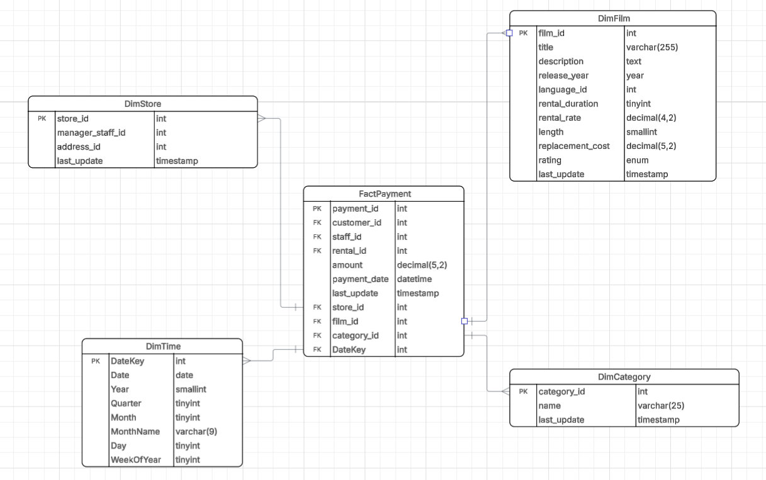

Q5 – Value Analysis (Revenue and High-Value Products)
- Which films generate the highest total revenue (amount)?
- Which categories contribute the most sales overall?
- What are the top 10 films or categories by revenue for each month/quarter/year?
- What is the average payment amount per film or category?
- What is the total revenue per film within each store?
- Which stores generate the most revenue from specific categories or films?
- What is the contribution percentage of each category to total company revenue?
- Which films have the highest rental rate vs. actual revenue generated?
- What is the relationship between film length or rating and revenue?

Q3 – Geographic Footprint (Where the Business Operates and Performs)
- Which stores (by store_id) generate the highest total revenue?
- How does revenue differ across stores over time?
- Which store locations perform better for certain categories or films?
- What are the top-performing stores in terms of monthly/quarterly sales?
- How much does each store contribute to overall company revenue (percentage share)?
- Are there seasonal sales differences between stores?
- Which stores sell the widest variety of categories or films?

Q4 – Operational Timeline (Trends and Seasonality)
- What are the peak sales months and quarters (based on DateKey)?
- How does total revenue change over time (monthly, quarterly, yearly)?
- Which categories or films perform best in specific time periods?
- Are there seasonal trends in payment amounts or transaction volume?
- What is the trend of total payments over the operational timeline (growth or decline)?
- How does film performance change over different years (e.g., older vs. newer films)?
Combined Insights (Q3 + Q4 + Q5)
- Which film categories perform best in specific stores and time periods?
- What are the top-performing films per store per month?
- How does revenue by category evolve across time and location?
- Are there any stores or film categories with consistent growth trends?
- What store-film-category combinations deliver the highest total revenue each quarter?

Task 2: Query list 2 in MongoDB

Business Scale Analysis: Count Total Customers
db.customer.aggregate([
{
$count: "total_customers"
}
]);

Business Scale Analysis: Count Total Films
db.film.aggregate([
{
$count: "total_films"
}
]);

Stakeholder Identification: Identify Actors with Most Film Appearances
db.film_actor.aggregate([
{
$group: {
_id: "$actor_id",
film_count: { $sum: 1 }
}
},
{
$sort: { film_count: -1 }
},
{
$lookup: {
from: "actor",
localField: "_id",
foreignField: "actor_id",
as: "actor_info"
}
}
]);

Geographic Footprint: Count Customers per Country
db.customer.aggregate([
{
$lookup: {
from: "address",
localField: "address_id",
foreignField: "address_id",
as: "address_info"
}
},
{
$unwind: "$address_info"
},
{
$lookup: {
from: "city",
localField: "address_info.city_id",
foreignField: "city_id",
as: "city_info"
}
},
{
$unwind: "$city_info"
},
{
$lookup: {
from: "country",
localField: "city_info.country_id",
foreignField: "country_id",
as: "country_info"
}
},
{
$unwind: "$country_info"
},
{
$group: {
_id: "$country_info.country",
customer_count: { $sum: 1 }
}
},
{
$sort: { customer_count: -1 }
}
]);

Geographic Footprint: store address
db.store.aggregate([
{
$lookup: {
from: "address",
localField: "address_id",
foreignField: "address_id",
as: "address_info"
}
},
{
$unwind: "$address_info"
},
{
$lookup: {
from: "city",
localField: "address_info.city_id",
foreignField: "city_id",
as: "city_info"
}
},
{
$unwind: "$city_info"
},
{
$lookup: {
from: "country",
localField: "city_info.country_id",
foreignField: "country_id",
as: "country_info"
}
},
{
$unwind: "$country_info"
},
{
$project: {
_id: 0,
store_id: "$store_id",
address: "$address_info.address",
district: "$address_info.district",
city: "$city_info.city",
country: "$country_info.country"
}
}
]);

Calculate Total Sales per Store
db.payment.aggregate([
{
$lookup: {
from: "rental",
localField: "rental_id",
foreignField: "rental_id",
as: "rental_info"
}
},
{
$unwind: "$rental_info"
},
{
$lookup: {
from: "inventory",
localField: "rental_info.inventory_id",
foreignField: "inventory_id",
as: "inventory_info"
}
},
{
$unwind: "$inventory_info"
},
{
$group: {
_id: "$inventory_info.store_id",
total_sales: { $sum: "$amount" }
}
},
{
$sort: { total_sales: -1 }
},
{
$lookup: {
from: "store",
localField: "_id",
foreignField: "store_id",
as: "store_info"
}
}
]);

Timeline: Find Earliest and Latest Rental Dates
db.rental.aggregate([
{
$group: {
_id: null,
earliest_rental: { $min: "$rental_date" },
latest_rental: { $max: "$rental_date" }
}
}
]);

Timeline: Count Rentals per Month
db.rental.aggregate([
{
$group: {
_id: {
year: { $year: "$rental_date" },
month: { $month: "$rental_date" }
},
rental_count: { $sum: 1 }
}
},
{
$sort: { "_id.year": 1, "_id.month": 1 }
}
]);

Value Analysis: Calculate Total Revenue
db.payment.aggregate([
{
$group: {
_id: null,
total_revenue: { $sum: "$amount" }
}
}
]);

Value Analysis: Calculate Total Revenue per Film Category
db.film.aggregate([
{
$lookup: {
from: "film_category",
localField: "film_id",
foreignField: "film_id",
as: "categories"
}
},
{
$unwind: "$categories"
},
{
$lookup: {
from: "category",
localField: "categories.category_id",
foreignField: "category_id",
as: "category_info"
}
},
{
$unwind: "$category_info"
},
{
$lookup: {
from: "inventory",
localField: "film_id",
foreignField: "film_id",
as: "inventory_items"
}
},
{
$unwind: "$inventory_items"
},
{
$lookup: {
from: "rental",
localField: "inventory_items.inventory_id",
foreignField: "inventory_id",
as: "rentals"
}
},
{
$unwind: "$rentals"
},
{
$lookup: {
from: "payment",
localField: "rentals.rental_id",
foreignField: "rental_id",
as: "payments"
}
},
{
$unwind: "$payments"
},
{
$group: {
_id: "$category_info.name",
total_revenue: { $sum: "$payments.amount" }
}
},
{
$sort: { total_revenue: -1 }
}
]);

Actor Film Category Count
db.actor.aggregate([
{
$lookup: {
from: "film_actor",
localField: "actor_id",
foreignField: "actor_id",
as: "film_actor_info"
}
},
{
$unwind: "$film_actor_info"
},
{
$lookup: {
from: "film",
localField: "film_actor_info.film_id",
foreignField: "film_id",
as: "film_info"
}
},
{
$unwind: "$film_info"
},
{
$lookup: {
from: "film_category",
localField: "film_info.film_id",
foreignField: "film_id",
as: "film_category_info"
}
},
{
$unwind: "$film_category_info"
},
{
$lookup: {
from: "category",
localField: "film_category_info.category_id",
foreignField: "category_id",
as: "category_info"
}
},
{
$unwind: "$category_info"
},
{
$group: {
_id: {
actor_name: { $concat: ["$first_name", " ", "$last_name"] },
category_name: "$category_info.name"
},
film_count: { $sum: 1 }
}
},
{
$sort: { "_id.actor_name": 1, film_count: -1 }
}
]);

Task 3: Code for ETL tool for migrating from SQL Server to MongoDB
Python file name sakila in folder Codes

TASK 4: A description of, or the code for, indexes you create on your collections for performance optimization:

Index 1: Payment and Rental Optimization
db.payment.createIndex({ rental_id: 1 });
Explanation:
This index is created on the rental_id field in the payment collection. It helps MongoDB quickly locate all payments linked to a specific rental record without scanning the entire collection. This index improves performance for payment lookup queries and aggregation pipelines that connect payments to rentals.

Index 2: Rental and Inventory Lookup Efficiency
db.rental.createIndex({ rental_id: 1, inventory_id: 1 });
Explanation:
This compound index includes both rental_id and inventory_id fields from the rental collection. It improves query performance for searches and aggregations involving both the rental transaction and the inventory item rented. Using two fields in one index allows MongoDB to efficiently handle combined filters and join operations.

Index 3: Inventory Availability by Store
db.inventory.createIndex({ store_id: 1 });
Explanation:
This index focuses on the store_id field in the inventory collection. It helps optimize queries that check which films or inventory items belong to a particular store. It reduces the time needed to fetch store-related inventory information, which is important for reports comparing store performance or stock levels.

Index 4: Address and City Lookup Optimization
db.address.createIndex({ address_id: 1, city_id: 1 });
Explanation:
This compound index combines address_id and city_id fields from the address collection. It enhances performance for queries that join customer or store addresses with their corresponding cities. By indexing both fields together, MongoDB can more efficiently match address records during location-based lookups.

Index 5: City and Country Relationship Index
db.city.createIndex({ city_id: 1, country_id: 1 });
Explanation:
This index helps speed up queries that connect cities with their respective countries. It’s useful when retrieving all cities within a given country or when joining customer or store data with location information. Indexing both city_id and country_id allows MongoDB to process these joins much faster.

Index 6: Country Reference Index
db.country.createIndex({ country_id: 1 });
Explanation:
This index is created on the country_id field in the country collection. It improves lookup and filtering performance when identifying or grouping customers, stores, or cities by country. This is helpful in analytical queries that summarize data at the country level.

Index 7: Film and Category Join Optimization
db.film_category.createIndex({ film_id: 1 });
Explanation:
This index targets the film_id field in the film_category collection. It enhances query speed when joining or filtering films by category. Since many reports and analyses rely on film-category relationships, this index ensures quick access to the relevant records.

Index 8: Inventory Film Lookup Efficiency
db.inventory.createIndex({ film_id: 1, inventory_id: 1 });
Explanation:
This compound index improves queries that retrieve inventory items based on a specific film. It helps when determining how many copies of a film are available and in which stores they are located. The combination of film_id and inventory_id ensures efficient multi-field lookups.

Index 9: Payment-Rental Relationship Index
db.payment.createIndex({ rental_id: 1 });
Explanation:
This index is designed to improve performance for queries that connect payments with their related rentals. It ensures fast lookups for payment details, refunds, or transaction summaries based on rental records, minimizing resource use during aggregation.

